iCompute – Week 9

You are going to make a “pac man” style game. The goal will be to control your character to pick up one random computer part. A monitor, a keyboard, a tablet, or a CPU. There will be ghosts trying to catch you. The four objects are in the different corners. When the game starts, you should pick one at random and give a clue. For example, if we had a “mouse” on the screen a good clue for you character to say would be: “let’s go get the thing that controls the cursor!”

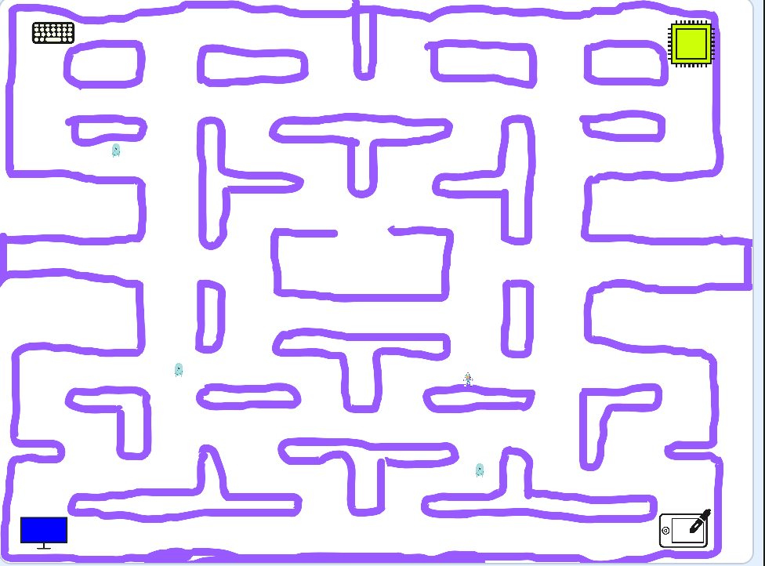

Ghosts should move at random and change direction if they hit the wall. Your character should move based on the arrow keys. If a ghost touches your character the game ends. If you touch the wrong object (the clue was for the keyboard and you touched the monitor) you lose and the game end. If you touch the right object you win!

- Before you start programming, decide on the clues you want to use (make them related to what the thing is for or how it’s used. Don’t pick something like the color):
CPU:

Keyboard:

Tablet:

Monitor:

- What variables do you think you will need? There are 3 ghosts, 4 objects, and one space girl (your character). Think through what you need to keep track of.

- Program your game. Don’t forget to press save often!! Work as a team.

- If you don’t finish in class, try to work on your game at home: https://scratch.mit.edu/projects/305246761/

